|  |  |
| --- | --- |
| GEN AI LEARNING  **Complete Generative AI Learning – New Year Challenge** | WRITTEN BY: ALOY |

***Day – 24***

SET UP QUADRANT DB LOCALLY

STEP 1: INSTALL DOCKER DESKTOP IN WINDOWS 11.

STEP 2: FOLLOW THE INSTRUCTION MENTIONED IN <https://qdrant.tech/documentation/quickstart/>

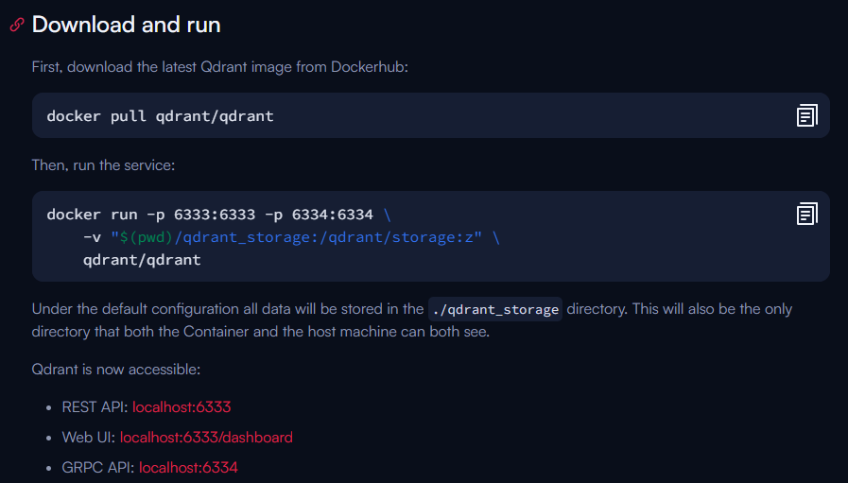

MODIFY THE COMMAND AS PER YOUR LOCAL MACHINE PATH LIKE BELOW

docker run -p 6333:6333 -p 6334:6334 -v "H:/Interview Preparation/Coding/GenAI/MultimodalRAG/qdrant_storage:/qdrant/storage:z" qdrant/qdrant

ONCE THE COMMAND RUN SUCCESSFULLY THE DOWNLOADED IMAGE WILL BE DISPLAYED,



It will also be visible in command prompt as below,

